All About Me

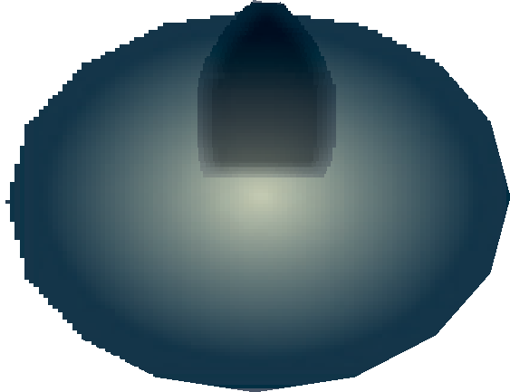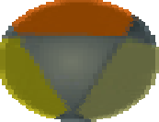

|  |  |
| --- | --- |
| **I like to be called:** | |
| **Something about me:** | **These are my people:** |
| My birthplace: |  |
| My occupation: |  |
| Interest/hobbies: |  |
| **This matters to me most:** |  |

# I need you to know:

**I use:**

Walker Cane Glasses

Hearing aid Dentures

Other:

# When talking to me:

Eye contact: Yes No Smile: Yes No Gentle tone: Yes No Stand close: Yes No

# Sleep preferences:

I wake up at: I go to bed at:

Speak from: Left Right Speak loudly: Yes No

Gentle touch to get my attention first: Yes No

Other:

# My care do’s and dont’s:

I speak these languages:

Consent to post form at bedside provided by:  Patient  SDM

Date of consent (DD/MM/YYYY): *(documented in the progress notes)*

Document it has been scanned into the patient’s electronic medical record:  Yes  No

Form #6706, Revised July 2023